Design and Manufacturing

Project aim
Create a prototype board for the school to implement into a cubesat. The aim was to create a single board which combines the Sparkfun Triad Spectoscopy Sensor with a Raspberry Pi 0 2w.
This part is currently out of stock, and the sensors are scheduled for obsolescence.

Design considerations
The first step was to recreate the circuit necessary for the chips. An important thing to note is that the Sparkfun circuit is out of date as it uses the old version of the firmware.
Use the latest datasheet which can be found here
The firmware changes around some of the pins.

The main board was aimed to be designed to the librecube standards
This set the physical dimensions of the board and a limit on the height of components attached to it.

Early in the design phase it was decided to split the circuit into two boards.
One main board with a perpendicular smaller board attached with right angled connectors.
This was done due to uncertainty as to where the board would be placed in the cubesat. If the sensors were placed directly onto s typical cubesat board it would be pointing directly at another board (unless it was on the top layer which was not guaranteed.
The sensor board was initially designed to not exceed the height of 8.76 mm. This was achieved after some difficult routing but due to the height of the right-angled connector, it would not have been possible to mount it to the board to the mainboard.
The sensor board was redesigned to have a height of 12mm which was much easier to route and remained between the 16mm spacing between boards (assuming nothing is placed underneath the PCB above it.

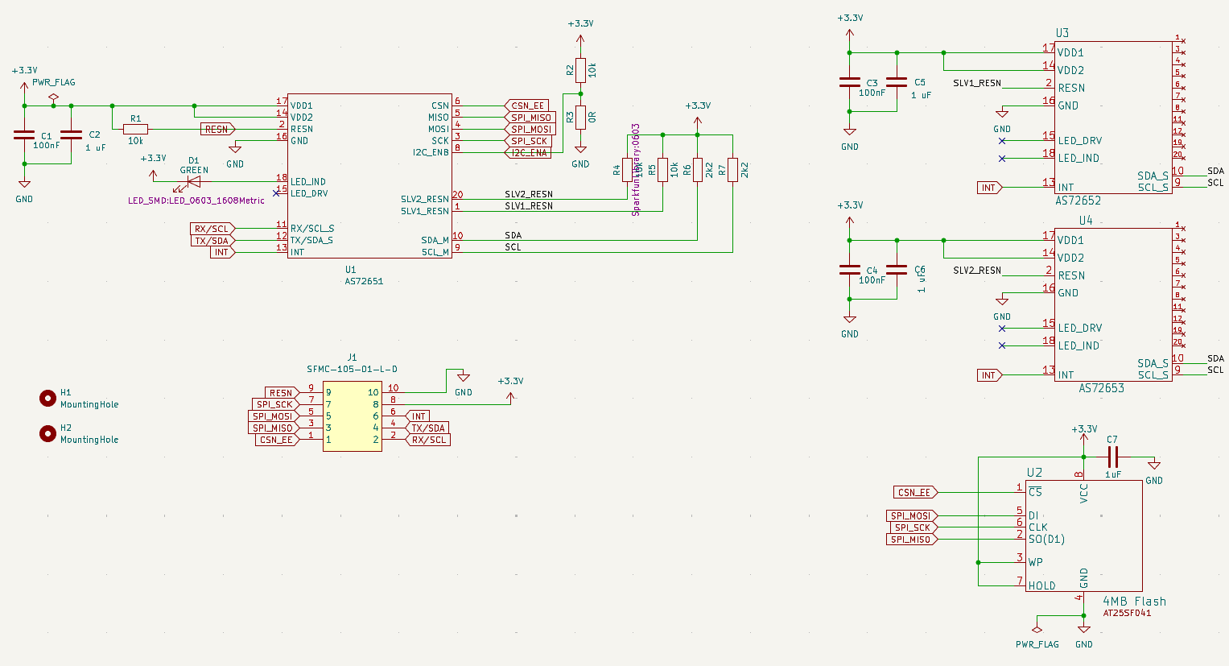
Schematic

Routing
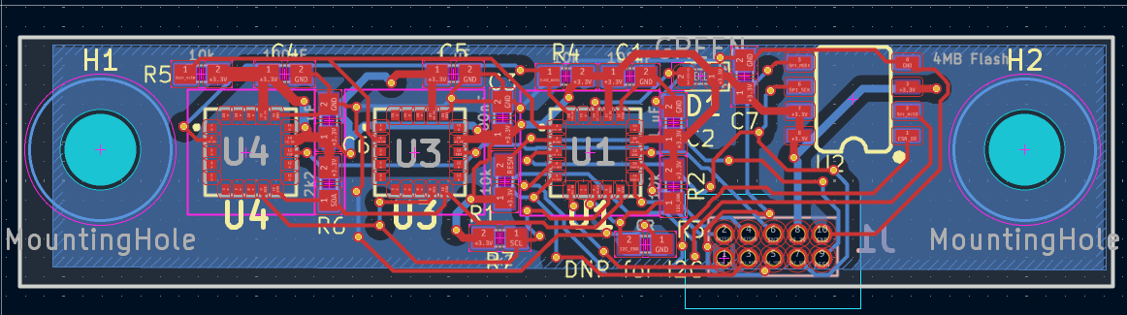

3D view

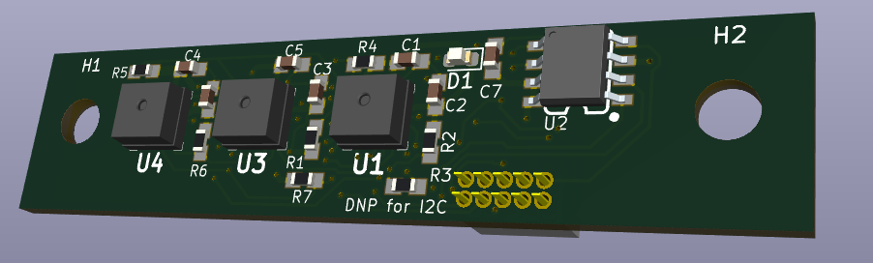

To provide flexibility, it was decided to make this sensor board to be able to be placed in 3 different locations each pointing to a different side of the cubesat.

The school had initially used UART to communicate with the sensors so it was decided to add the flexibility of switching between UART and I2C by using 0 ohm resistors.

Additionally, the option to test the UART between layers of the cubesat was added by connecting the pi to the stacking connectors.

Final Assembly
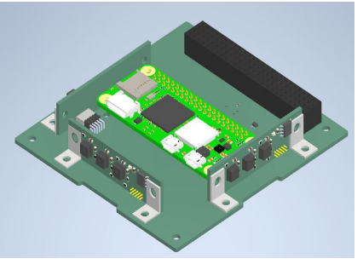
Includes the 3 possible configurations

Assembly
The PCBs were assembled by hand and heated using a hot plate.

An initial test of the sensor board was done.
This was done by using a power supply.
A positive result was determined by having the PCB draw no more than 15mA and the LED flashing.

The LED flashing is due to the sensors waiting to have their firmware uploaded.
If the firmware had been successfully uploaded, then the light would remain red and not flash.

Issues
There were some issues with uploading the firmware once the chip was already on the board. This could have been due to difficulty in reaching the pins with the programmer or something else. There were also some issues with reading certain chips after they had been flashed and some started flashing after they had been power cycled.

Eventually, some sensor boards would remain red but when they were connected to the main board they would start flashing.
We were uncertain as to why this was the case.
This did not happen with one board which had a short between the SDA and SCL line so could not be used.
It was uncertain as to whether this was due to the board being correct apart from this or it remained solid due to another fault.

There was also an issue with overheating of the SD card holder. This would get very hot to touch after just a few seconds, but the issue was fixed when we changed SD cards.

To test whether the boards worked we used a script to check whether the pi could communicate with the board over I2c.
All tests for this failed.
A successful test would show presence of something at the memory address 49 however all tests showed nothing there.

We could not find out what was the cause of the issues.

